| **NAME** | **Ms. Adwait Purao** |
| --- | --- |
| **UID** | **2021300101** |
| **DIV** | **TE CE : BATCH B** |
| **Assignment 3 : List a Company that brought major change in their strategies under Configuration frameworks that used Network Configuration** | |

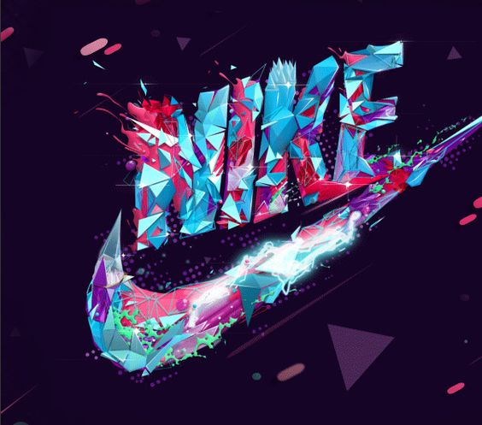



**Introduction:** Nike, the global leader in athletic apparel and footwear, has effectively harnessed the power of social media to cement its position as a iconic brand. Through a strategic and innovative approach to social networking, Nike has cultivated a passionate community of athletes and fitness enthusiasts, fostering brand loyalty, driving product awareness, and staying ahead of the curve in the highly competitive sportswear industry.

**Social Network Configuration Analysis:**

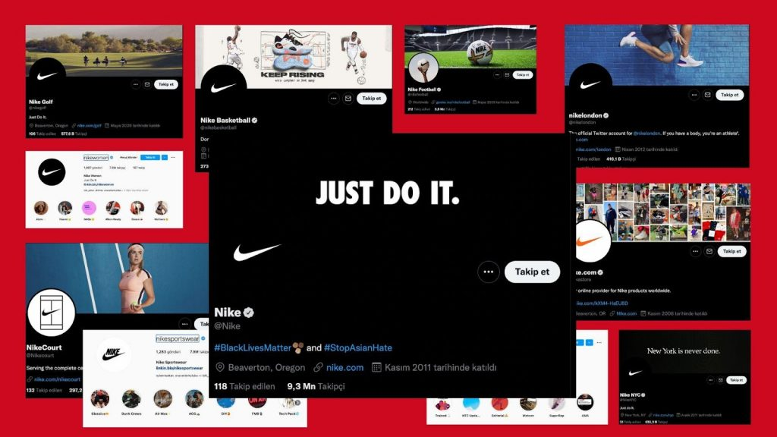

**a. Social Media Strategy:**

1. **Inspiring and Motivational Content:**

* Nike's social media strategy centers around creating inspiring and motivational content that resonates with its target audience of athletes and fitness enthusiasts. From powerful storytelling to visually captivating imagery, Nike's content aims to ignite passion, drive personal growth, and celebrate the human spirit.
* Content themes include athlete profiles, training tips, product showcases, and behind-the-scenes glimpses into Nike's design and innovation processes, providing followers with a comprehensive understanding of the brand's commitment to excellence.

1. **User-Generated Content (UGC) Integration:**

* Nike actively encourages its customers and fans to share their athletic journeys and experiences with its products by leveraging user-generated content (UGC) across its social media channels. The brand runs UGC-driven campaigns, inviting followers to share photos, videos, and stories using specific hashtags or tagging the brand.
* Nike frequently features UGC in its marketing materials, website, and advertising campaigns, amplifying the voices of its customers and fostering a sense of community among its followers.

1. **Community Engagement and Interaction:**

* Nike prioritizes active engagement with its social media community, responding promptly to comments, queries, and mentions across platforms. The brand's social media team fosters two-way communication, addressing customer concerns, offering product recommendations, and celebrating customer achievements.
* Nike hosts regular polls, contests, and interactive Q&A sessions to solicit feedback, gather insights, and foster dialogue with its audience, creating a sense of inclusivity and brand loyalty.

1. **Influencer Collaborations and Partnerships:**

* Nike strategically collaborates with influencers, athletes, and celebrities to amplify its brand messaging and reach new audiences. The brand partners with individuals who embody its values and resonate with its target demographic.
* Influencers and athletes often share their training routines, product experiences, and personal stories, generating buzz and excitement around the brand's offerings.

1. **Product Launch and Marketing Campaigns:**

* Nike leverages its social media platforms as primary channels for announcing and promoting new product launches and marketing campaigns. The brand builds anticipation and excitement through teaser posts, behind-the-scenes previews, and interactive content leading up to launch day.
* Nike's marketing campaigns often incorporate user-generated content, influencer collaborations, and interactive elements to engage its audience and drive product awareness and interest.

b. **Networking Approach:**

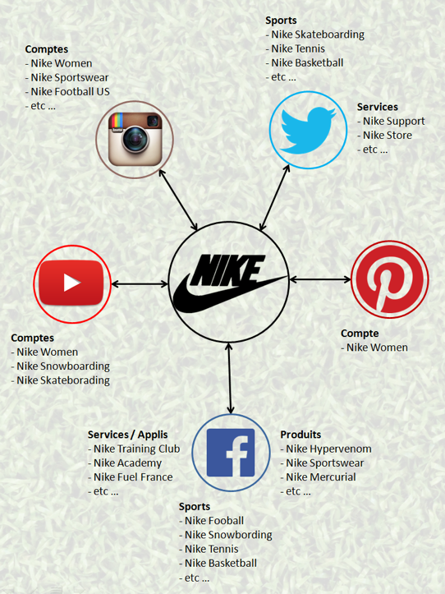

1. **Personalized Interaction and Customer Support:** Nike adopts a personalized approach to networking on social media, aiming to establish genuine connections with its audience. The brand's social media team actively responds to customer inquiries, feedback, and concerns, providing prompt and tailored support. Nike's customer-centric approach to networking helps to build trust and loyalty among its followers, positioning the brand as accessible and responsive to its community's needs.
2. **Community Building and Engagement:** Nike places a strong emphasis on community building through its networking approach on social media. The brand fosters a sense of belonging and inclusivity by creating spaces where followers can connect, share their athletic experiences, and celebrate their achievements. Nike's social media channels serve as platforms for users to engage in discussions, seek advice from fellow athletes, and participate in brand-driven initiatives, fostering a vibrant and engaged community.
3. **Brand Advocacy and Loyalty Programs:** Nike leverages brand advocacy and loyalty programs as key components of its networking strategy on social media. The brand identifies and cultivates relationships with its most passionate customers, empowering them to become brand advocates and ambassadors. Through loyalty programs and exclusive benefits, Nike rewards its most dedicated followers, encouraging them to share their experiences, provide feedback, and amplify the brand's messaging within their social circles.
4. **Collaborative Content Creation:** Nike collaborates with influencers, athletes, and industry experts to co-create engaging content for its social media channels. These collaborations often take the form of workout videos, training tips, or educational content, providing followers with valuable insights and expertise from trusted sources.

**c. Engagement Metrics:**

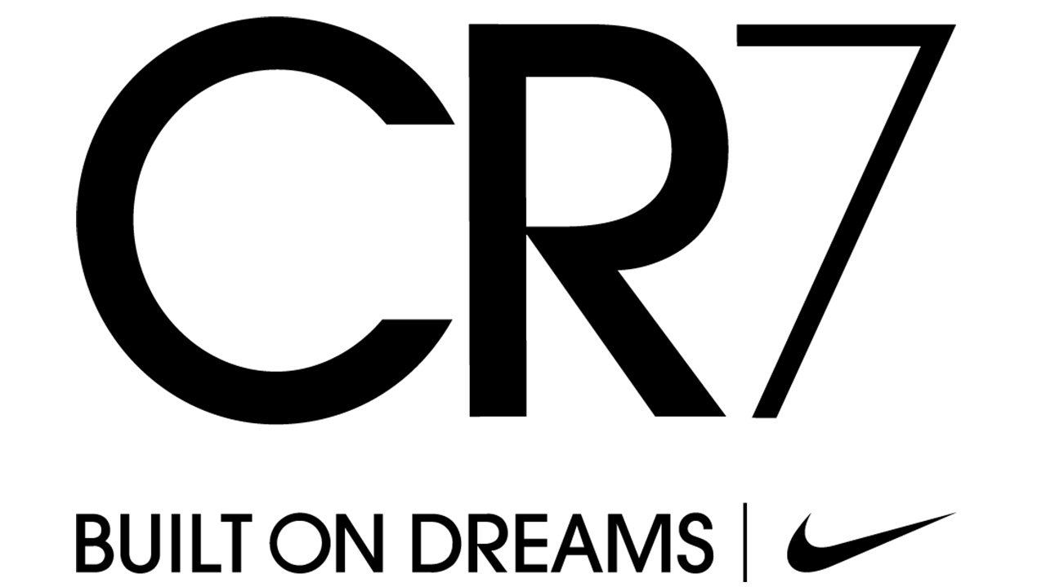

Nike has effectively engaged its audience across various platforms, notably on Instagram where it boasts a massive following of 306.8 million. Despite this impressive reach, the engagement rate stands at around 0.03%. In the past three months alone, Nike has garnered a remarkable 8,832,062 engagements while sharing just 58 posts on their account.

In terms of financial performance, Nike has consistently seen revenue growth globally from fiscal years 2005 to 2023. A substantial portion of their revenue now stems from their direct-to-consumer initiative, Nike Direct, which contributed $10 billion in sales during 2018.

Nike's dedication to innovation and enhancing customer experiences has been pivotal in achieving these remarkable engagement metrics. They leverage analytics to personalize the customer journey and foster stronger connections with their audience. This includes offering apps for access to the Nike Plus rewards program, personalized workouts, and exclusive event access.

These statistics underscore Nike's effective engagement strategies and their ongoing commitment to innovation and customer satisfaction.

**d. Collaboration and Partnerships:**

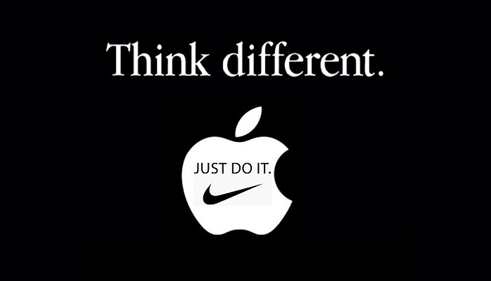

Nike has a rich history of successful collaborations and partnerships across various sectors. They've partnered with governments, NGOs, and industry groups to drive positive change. For instance, Nike is a founding member of the Sustainable Apparel Coalition (SAC), a collaborative effort involving over 200 leading apparel and footwear brands, retailers, suppliers, academics, and NGOs, dedicated to reducing the environmental impacts of apparel and footwear products. Nike has been actively engaged in SAC since 2009.

In terms of labor practices, Nike became a member of the Fair Labor Association (FLA) in 1999. The FLA is a collaborative initiative aimed at improving working conditions in factories worldwide, involving socially responsible companies, colleges and universities, and civil society organizations.

Nike has also formed partnerships with influential figures in the sports industry such as Kobe Bryant, Cristiano Ronaldo, LeBron James, Kevin Durant, Serena Williams, and others. Between 2012 and 2017, Nike invested more than 3 billion dollars in influencer marketing.

Additionally, Nike has collaborated with notable brands like Apple, Beats by Dre, and CLOT. For instance, Nike's 2006 collaboration with Apple resulted in the creation of the Nike+ Run Club App, which positioned Nike as a leader in the digital fitness domain.

These collaborations and partnerships have been instrumental in Nike's growth and success.

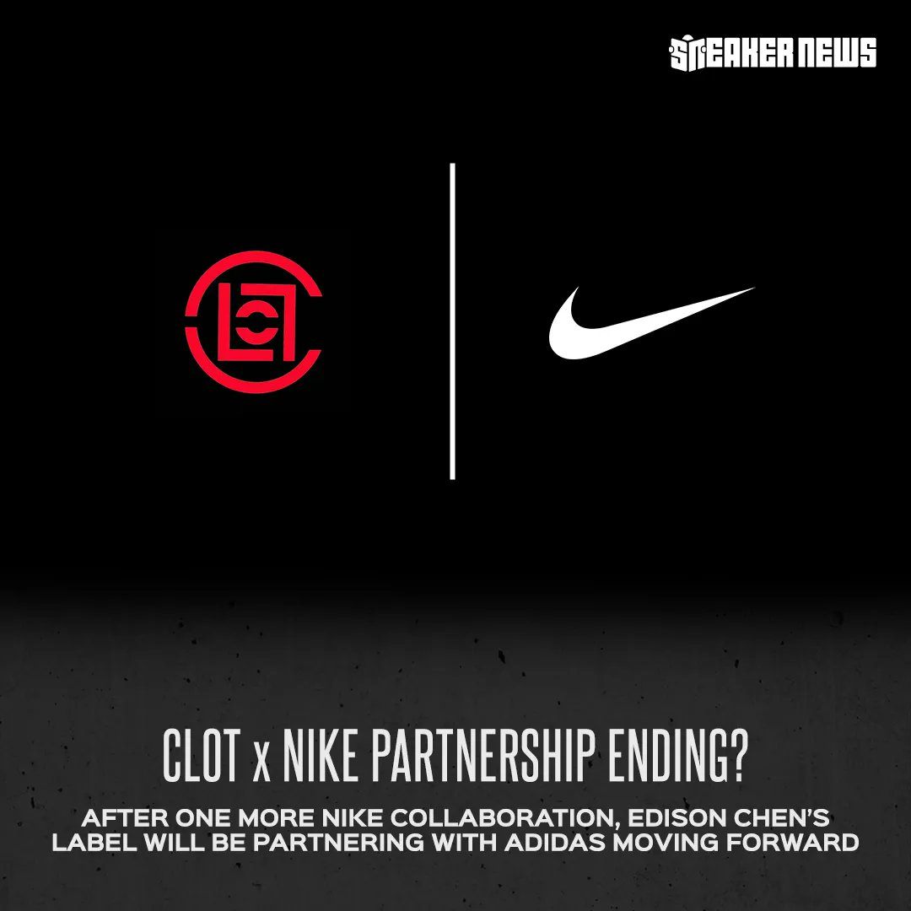

**Sales Figures :**



| **Fiscal Year** | **Annual Revenue** | **Growth** |
| --- | --- | --- |
| 2022 | $46.71 billion | - |
| 2023 | $51.22 billion | 9.65% |
| 2024 (Feb) | $51.58 billion | 1.89% |

| **Quarter** | **Quarterly Revenue** | **Growth** |
| --- | --- | --- |
| **2024 (Feb)** | **$12.43 billion** | **0.31%** |

| **Investor** | **Share** |
| --- | --- |
| **Philip Knight and Travis Knight** | **Over 97% of Class A shares** |

Regarding investors, over 97% of Nike's Class A shares are held by Philip Knight and his son Travis Knight, along with their holding companies and trusts. Consequently, the Knight family holds substantial influence in the company's decision-making processes. Nike has a commendable history of investing to drive growth and consistently enhancing returns to shareholders, boasting 20 consecutive years of increasing dividend payouts.

These statistics showcase Nike's strong financial performance and its capacity to generate value for its shareholders, while also highlighting the company's potential for future growth.

**SWOT Analysis:**

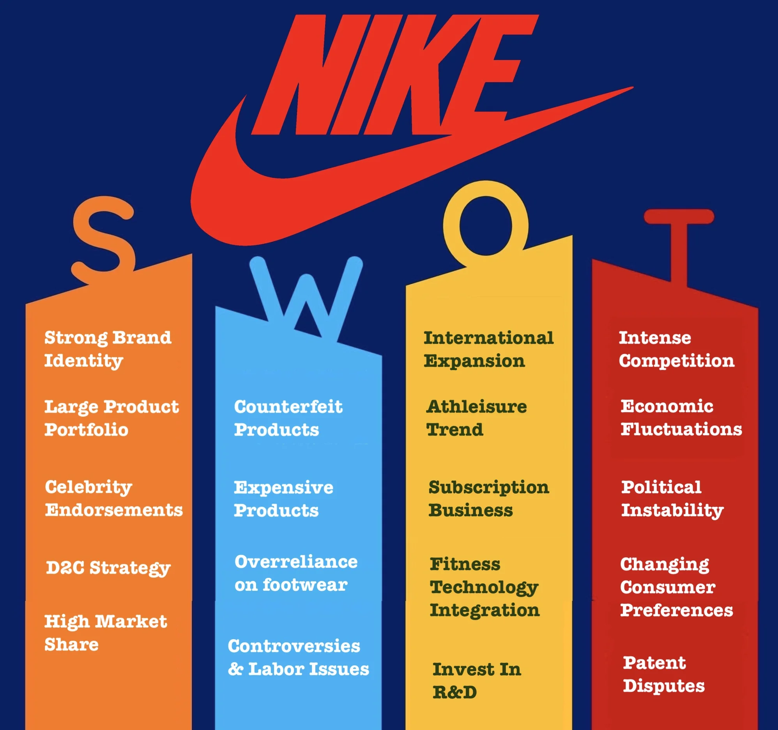

**Impact and Future Outlook:**

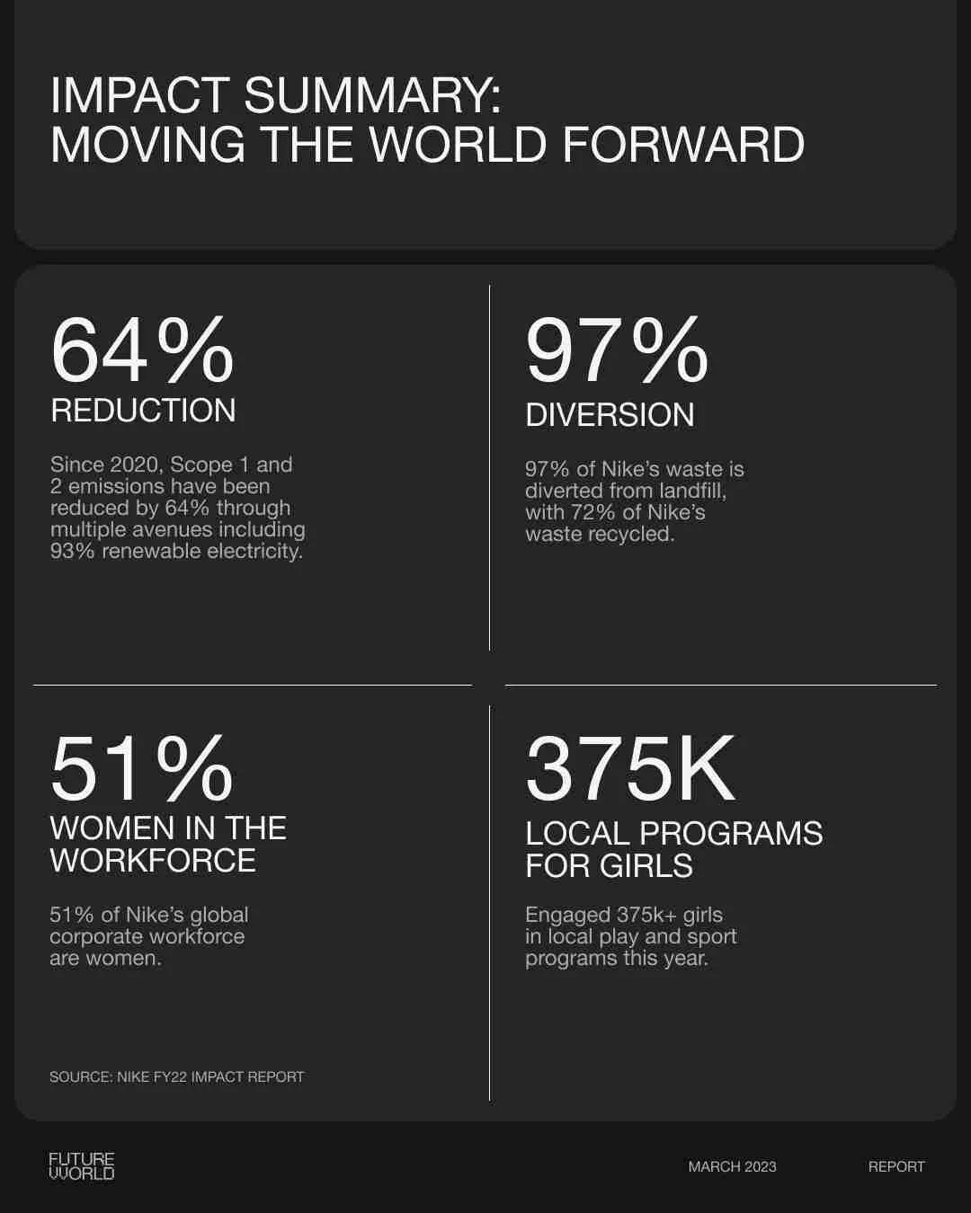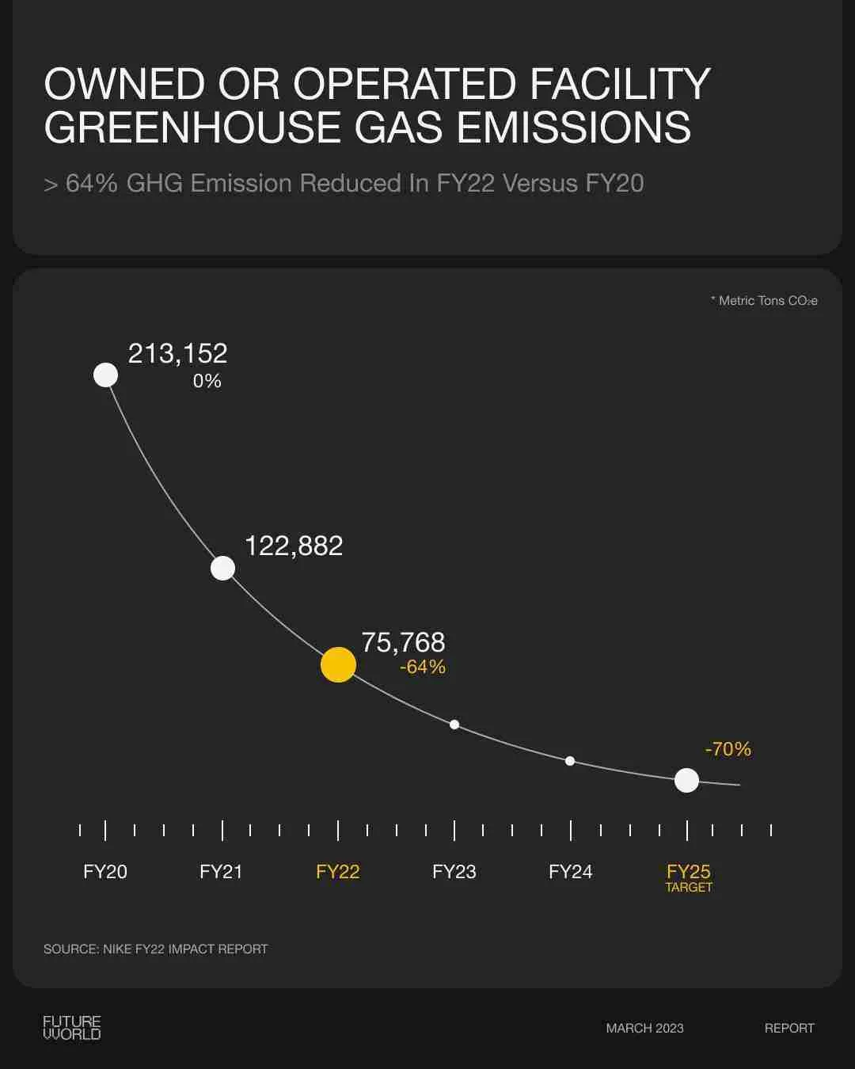

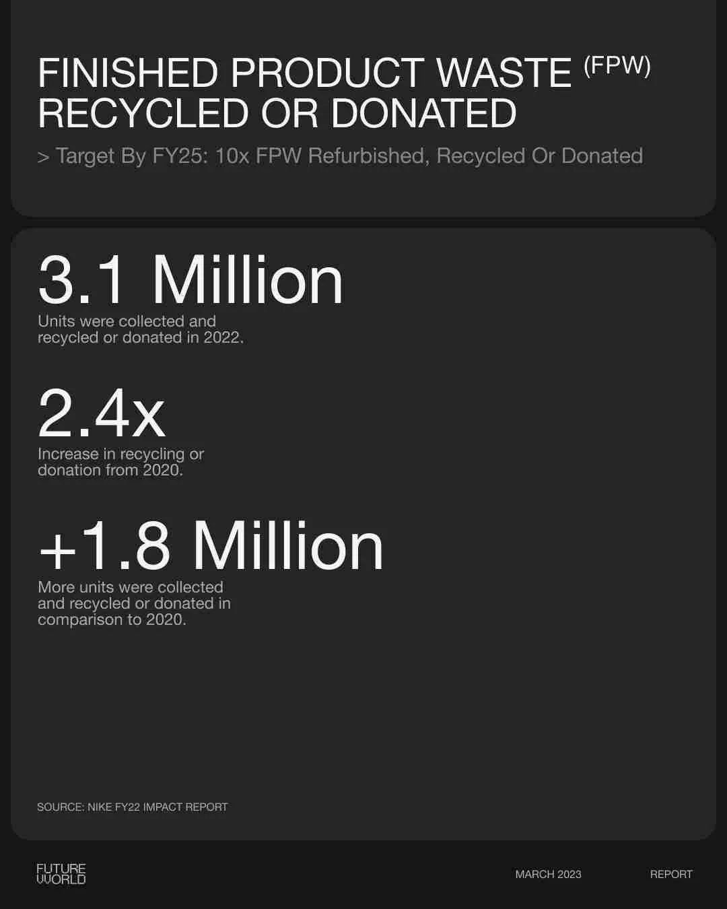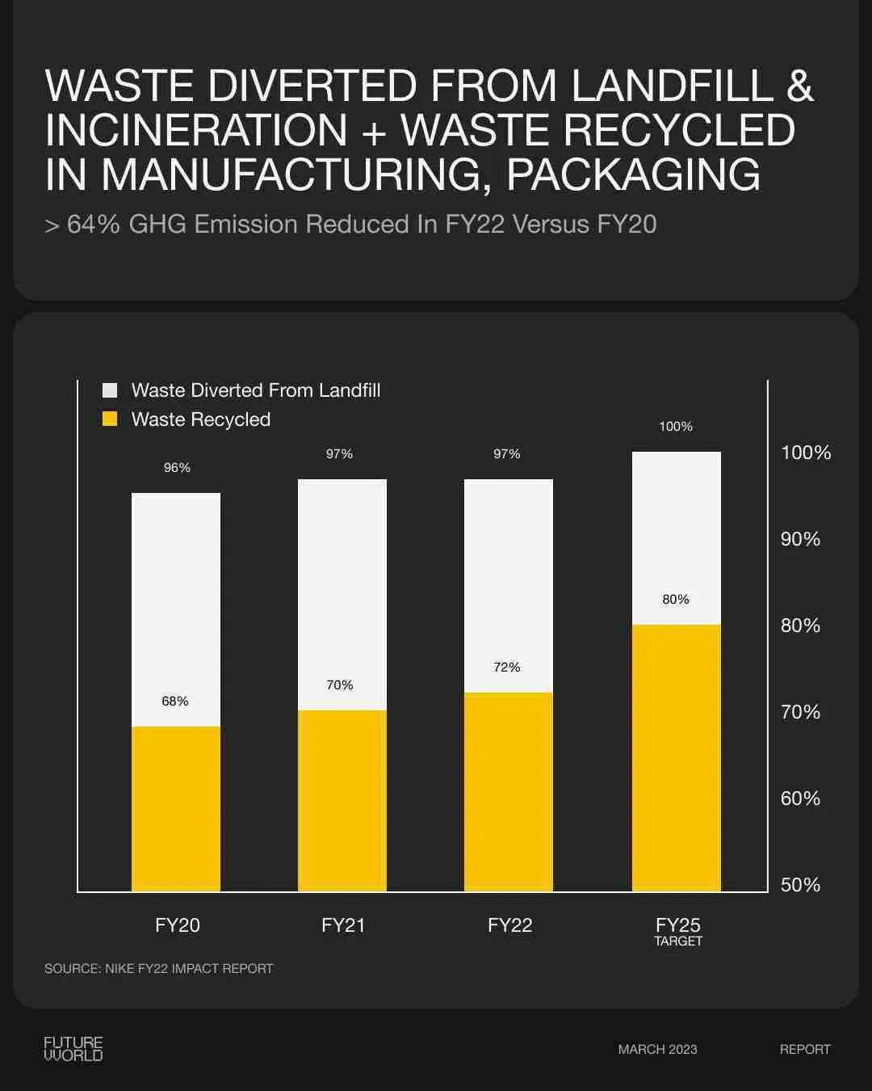

Impact:

* In FY22, Nike showed strong progress against its 29 targets for 2025.
* Women represented 51 percent of Nike’s global corporate workforce in FY22.
* Nike maintained 1:1 pay equity for women globally and U.S. racial and ethnic minorities.
* In the last two fiscal years, Nike spent $777 million on diverse suppliers, including numerous women-led businesses.
* More than 375,000 girls accessed play and sport through Nike's partners’ diverse programs.
* Nike invested $149 million in communities around the world, with a focus on women, girls and their Black Community Commitment (BCC).
* Nike reduced the greenhouse gas (GHG) emissions of its owned or operated facilities by nearly 40% from FY21 to FY22.
* Nike used 39 percent environmentally preferred materials in its products, reducing GHG emissions by more than 182,000 metric tons.

Future Outlook:

* Nike holds a 38.68% total market share.
* Advertising and promotion spends amount to $4.06 billion.
* The average target predicts an increase of 25.63% from the current stock price.
* On average, Wall Street analysts predict that Nike's share price could reach $115.07 by Apr 11, 2025.

**Conclusion:**

Through its innovative approach to social network configuration, Nike has set the benchmark for how brands can leverage social media to build communities, foster brand loyalty, and drive product awareness. By prioritizing inspiring content creation, community engagement, and collaborative partnerships, Nike has created a social media ecosystem that resonates deeply with its target audience of athletes and fitness enthusiasts. As Nike continues to evolve its social networking strategies, it remains well-positioned to drive further growth, expand its global reach, and shape the future of athletic marketing in the digital age.